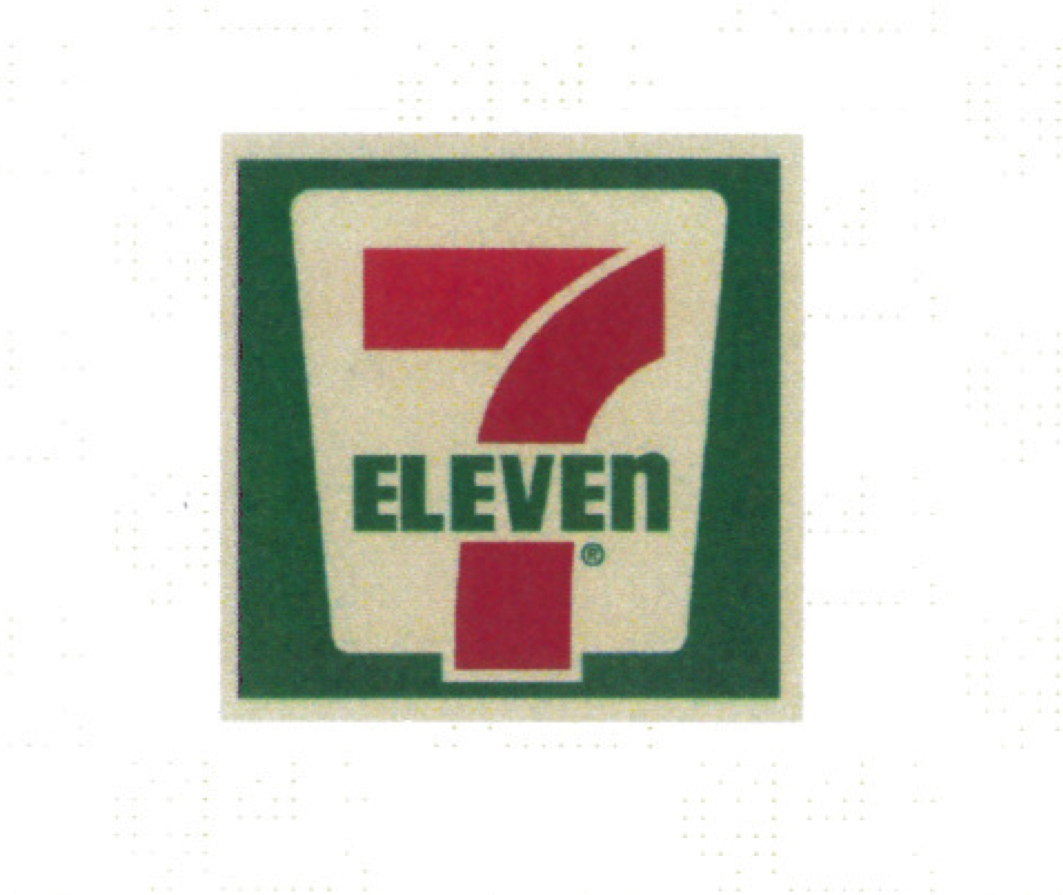

June 24, 2016

The Honorable Adam Gray
Chair, Assembly Governmental Organization Committee
1020 N Street, Room 156
Sacramento, CA 95814

RE: SB 1400 (Wieckowski) Retail Tobacco Licenses – OPPOSE

Dear Assembly Member Gray:

On behalf of 7-Eleven, I am writing to express our opposition to SB 1400 (Wieckowski), which will only allow the sale of tobacco at tobacco stores where at least 60% of sales are from tobacco products. This bill will significantly hurt our franchisees, who sell tobacco responsibly to our customers. 7-Eleven focuses on meeting the needs of convenience-oriented guests by providing a broad selection of fresh, high-quality products and services at everyday fair prices, speedy transactions and a clean, friendly shopping environment.

The California Department of Public Health, found that in 2014, 18.4% of tobacco stores sold tobacco to minors, while all other store types are at less than 7.6% on average. Furthermore, tobacco sales to minors has dramatically decreased from 21.7% in 1997 to 9.0% in 2014. Our franchisees would like to continue to responsibly sell tobacco in California, which is a legal product for which we have just increased the smoking age from 18 to 21.

Currently, our franchisees sell other restricted products such as alcohol and do so successfully and responsibly to our customers. While revenue for tobacco products has dropped over the years, it continues to be a product we would like to sell to our adult customers who chose to purchase the product. Furthermore, we are opposed to policies that discriminate against specified retail businesses. We are committed to reducing the number of minors who are sold tobacco products through our age verification system and believe SB 1400 is the wrong approach to achieving this goal.

For the reasons listed above, we must respectfully oppose SB 1400 (Wieckowski). If you have any questions, please feel free to contact our lobbyists John Latimer and Kate Bell with Capitol Advocacy at (916) 444-0400.

Sincerely,

Cc: Senator Bob Wieckowski, Author
Members, Assembly Governmental Organization Committee Committee
Kenton Stanhope, Committee Consultant
Jared Yoshiki, Assembly Republican Caucus

